PET SERVICE
  - All creatures great and small are welcome!
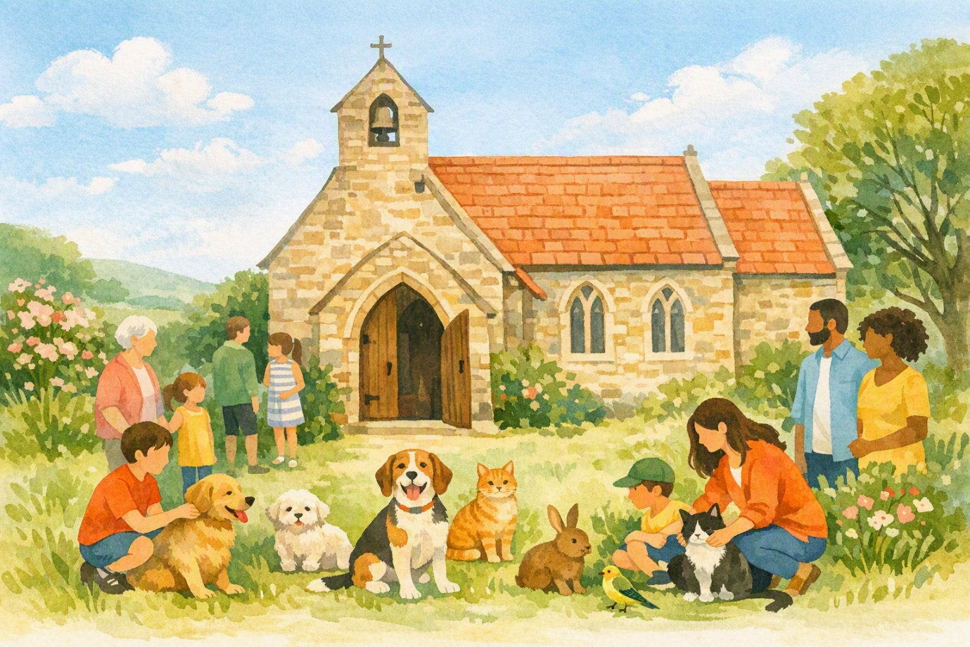
Bring your much-loved companion for a joyful church service and a special blessing for pets.
DATE  6th December 2026 | TIME  11:00 am
CHURCH & ADDRESS
St Bartholomew's Church
School Lane, Hints, B78 3DW

Please keep dogs on leads and smaller pets secure in suitable carriers. Owners remain responsible for their animals at all times.
Come along — with or without a pet!

