GOOD FRIDAY 2026

CHURCHES TOGETHER IN LICHFIELD

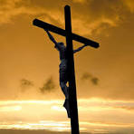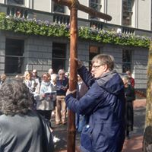

JOIN US ON THE WALK OF WITNESS

- A public statement of our Christian Faith
- Starts from Whittington pharmacy at 8.15am
- Pauses at Boley Park shopping precinct for a short act of worship
- Join the procession through the city on the old multi-story car park site by the bus station at 10.00am, with the second act of worship
- Join us at the next three worship stops – outside the Guild Hall, at the Bird Street/Bore Street junction, and at Dr Johnson’s birthplace
- Arrive at Lichfield Methodist Church for our Good Friday morning service at 11.00am

FROM CROSS TO TOMB
- Follow the Passion as told in St Matthew’s Gospel
- A reflective service of readings, hymns, and prayer
- Lichfield Cathedral – 7.30pm



